Lab-5

Airline database

**Code:**

CREATE DATABASE airlinedb;

USE airlinedb;

CREATE TABLE FLIGHTS

(

flno int,

ffrom varchar(30),

tto varchar(30),

distance int,

departs timestamp,

arrives timestamp,

price int,

primary key(flno)

);

CREATE TABLE AIRCRAFT

(

aid int,

aname varchar(30),

cruisingrange int,

primary key(aid)

);

CREATE TABLE EMPLOYEES

(

eid int,

ename varchar(30),

salary int,

primary key(eid)

);

CREATE TABLE CERTIFIED

(

eid int,

aid int,

FOREIGN KEY(aid) REFERENCES AIRCRAFT(aid),

FOREIGN KEY(eid) REFERENCES EMPLOYEES(eid)

);

INSERT INTO FLIGHTS

VALUES (101,"Bangalore","Delhi",2500,'2005-05-13:07:15:31','2005-05-13:07:15:31',5000),(102,"Bangalore","Lucknow",3000,'2005-05-13:07:15:31','2005-05-13:11:15:31',6000),

(103,"Lucknow","Delhi",500,'2005-05-13:12:15:31','2005-05-13:17:15:31.000000',3000),(107,"Bangalore","Frankfurt",8000,'2005-05-13:07:15:31','2005-05-13:22:15:31',60000),

(104,"Bangalore","Frankfurt",8500,'2005-05-13:07:15:31','2005-05-13:23:15:31',75000),(105,"Kolkata","Delhi",3400,'2005-05-13:07:15:31','2005-05-13:09:15:31',7000);

SELECT * FROM FLIGHTS;

INSERT INTO AIRCRAFT VALUES (101,"747",3000),(102,"Boeing",900),(103,"647",800),(104,"Dreamliner",10000),

(105,"Boeing",3500),(106,"707",1500),(107,"Dream",120000);

SELECT * FROM AIRCRAFT;

INSERT INTO EMPLOYEES

VALUES (701,"A",50000),(702,"B",100000),(703,"C",150000),(704,"D",90000),

(705,"E",40000),(706,"F",60000),(707,"G",90000);

SELECT * FROM EMPLOYEES;

INSERT INTO CERTIFIED

VALUES (701,101),(701,102),(701,106),(701,105),(702,104),(703,104),(704,104),(702,107),

(703,107),(704,107),(702,101),(703,105),(704,105),(705,103);

SELECT * FROM CERTIFiED;

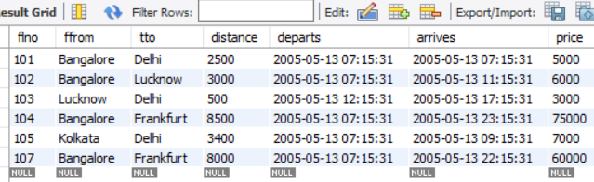

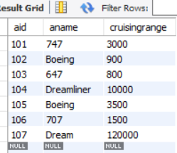 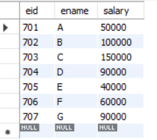

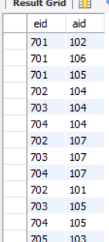

**Lab 4 Queries**

Queries and screenshot:

1. Find the names of aircraft such that all pilots certified to operate them have salaries more than Rs.80,000.
2. For each pilot who is certified for more than three aircrafts, find the eid and the maximum cruisingrange of the aircraft for which she or he is certified.
3. Find the names of pilots whose salary is less than the price of the cheapest route from Bengaluru to Frankfurt.
4. For all aircraft with cruisingrange over 1000 Kms, find the name of the aircraft and the average salary of all pilots certified for this aircraft.
5. Find the names of pilots certified for some Boeing aircraft.
6. Find the aids of all aircraft that can be used on routes from Bengaluru to New Delhi.
7. A customer wants to travel from Bangalore to Delhi with no more than two changes of flight. List the choice of departure times from Bangalore if the customer wants to arrive in Delhi by 6 p.m.
8. Print the name and salary of every non-pilot whose salary is more than the average salary for pilots

**1.** SELECT distinct a.aname

FROM AIRCRAFT a,EMPLOYEES e,CERTIFIED c

WHERE a.aid=c.aid and e.eid=c.eid and e.salary>80000;

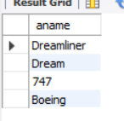

**2.**  SELECT e.eid,e.ename,max(a. cruisingrange)

FROM EMPLOYEES e,CERTIFIED c,AIRCRAFT a

WHERE e.eid=c.eid and a.aid=c.aid

group by e.ename

having count(c.aid)>3;



**3**. SELECT e.ename

FROM EMPLOYEES e

WHERE salary < (select min(price)

from FLIGHTS

where ffrom="Bangalore" and tto="Frankfurt");

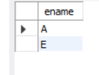

**4.** SELECT a.aname,a.cruisingrange,avg(e.salary)

FROM AIRCRAFT a,EMPLOYEES e,CERTIFIED c

WHERE c.eid=e.eid and c.aid=a.aid

group by a.aname

having a.cruisingrange > 1000;

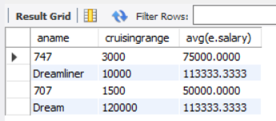

**5.** SELECT distinct e.ename

FROM EMPLOYEES e,CERTIFIED c,AIRCRAFT a

WHERE e.eid=c.eid and a.aid=c.aid and aname like "Boeing";

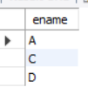

**6.** SELECT a.aid

FROM AIRCRAFT a

WHERE a. cruisingrange >= (select distance

from FLIGHTS

where ffrom="Bangalore" and tto="Delhi");

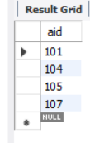

**7.** select departs

from flights f

where tto="Delhi" and arrives<="18:00:00" and f.ffrom="Bangalore"

union

(select departs

from flights

where ffrom="Bangalore" and tto in(select ffrom

from flights

where flno in(select flno

from flights f

where f.tto="Delhi" and f.ffrom in(select distinct(f.tto)

from flights f

where f.ffrom="Bangalore")

and arrives<="18:00:00")));



**8.**

SELECT E.ename, E.salary

FROM EMPLOYEES E

WHERE E.eid NOT IN ( SELECT DISTINCT C.eid

FROM CERTIFIED C )

AND E.salary >( SELECT AVG (E1.salary)

FROM EMPLOYEES E1

WHERE E1.eid IN

( SELECT DISTINCT C1.eid

FROM CERTIFIED C1 ) );

